| a
 |  |  |  |  |  | e |  |  |  |  |  |  |  | A | E |  |  |  |  |  |  | S |  |  |  |  | _ | _
 |  | 1. |  | P | i |  |  |  | H | E | _ | I | _ |  |  |  | l | S | , | _ | O |  |  |  | _ | s |  |  |  |  |  |  |  | ,
 |  |  |  |  |  |  |  |  | _ |  |  | S |  | P | K |  |  | _ |  |  | , | 0
 |  |  |  |  |  |  |  |  |  | r |  | n |  | B | C |  |  |  | S
 |  |  |  |  |  |  |  |  |  |  |  |  |  | _ |  |  |  |  | h |  |  | _
 |  |  |  |  |  |  |  | e | y |  | ll |  | i | g |  |  |  | a |  |  |  |  |  |  | r
 |  |  |  |  |  |  |  | t |  |  | r |  | s | t | r, |  |  |  |  |  |  | si | t |  |  |  | nd
 |  | 2 |  | b | l | t |  | r. | t |  | h |  |  |  |  |  |  | s | r |  | n
 |  |  |  | T |  | c |  | y |  |  |  |  |  | , | o |  |  |  |  |  |  | s |  |  |  |  | e |  |  |  | o
 |  | 3 |  | a |  |  |  | o |  | . | i |  |  |  |  |  | . |  | , | l | a |  |  |  | a
 |  |  |  | R |  |  |  |  |  |  |  |  |  | t | i
 |  | 4 |  |  | i |  |  | i |  | o |  |  | s. | n | s. |  | s
 |  | 5 |  | J | l |  |  |  | c |  |  | r
 |  | 6 |  | S |  |  | h |  |  | l |  |  | o | t |  | e |  |  |  |  |  | s |  |  |  |  |  |  | k |  |  | .
 |  | 7 |  | T |  | t | . |  |  | ui |  | , | u | li |  |  | t |  | , | d |  | i |  |  |  |  | d |  |  | t |  | n
 |  | 8 |  | s | s | d |  | u |  | h | l |  |  |  |  |  |  | il
 |  |  |  | R |  | i | e |  |  |  |  |  |  | o |  |  |  |  |  |  |  | il |  |  |  |  | r |  |  |  |  |  | .
 |  | 9 |  | i |  |  |  |  |  | c |  |  | r |  |  |  | n |  |  |  |  | o |  |  |  |  | a |  |  |  |  | s.
 |  |  |  |  | e | e |  | t |  |  | l |  |  | u |  | e |  | ri |  |  | le
 |  |  |  |  |  | .g

Powered by: www.schoolporto.com

System developed by -- lule -- 0752697211, info@schoolporto.com
| a
 |  | 1. |  |  |  |  |  |  | l |  | G
 |  |  |  |  | S |  | S |  |  | I
 |  |  |  |  |  |  |  |  |  |  | n.
 |  | S |  |  |  |  |  |  | _ |  |  | _
 |  |  |  |  |  |  | t |  |  |  | _
 |  | . | a |  |  |  |  |  |  |  | s | d | .
 |  | s |  |  |  |  |  |  |  |  | n
 |  | a |  |  |  |  |  |  |  |  | p
 |  | t |  |  |  |  |  |  |  |  | s
 |  | i |  |  |  |  |  |  |  |  | a
 |  | p |  |  |  |  |  |  |  |  | t
 |  | n |  |  |  |  |  |  |  |  | i

Powered by: www.schoolporto.com

System developed by -- lule -- 0752697211, info@schoolporto.com
3 | P a g e
 |  |  |  |  |  |  |  |  |  | _ |  |  | l | n | . |  |  | _ |  | h
 |  |  |  | . |  |  |  |  | y
 |  |  |  | . |  |  |  |  |  |  |  |  | _
 |  |  |  |  |  |  |  |  |  | , |  |  | _ |  |  |  |  | _
 |  |  |  |  |  |  |  |  |  |  | r |  |  |  |  |  |  | a

Powered by: www.schoolporto.com

System developed by -- lule -- 0752697211, info@schoolporto.com
| a
 |  |  |  |  |  |  |  |  |  |  |  | l |  |  | n |  | _ |  |  |  |  |  | e
 |  |  | . |  |  | c |  |  |  |  |  |  |  |  |  |  |  |  | i
 |  |  | . |  |  |  |  |  |  |  |  | _
 |  |  |  |  |  |  |  |  |  |  |  | _ |  |  | f |  | _
 |  |  |  |  | i |  |  |  |  |  |  |  |  |  |  |  | t

Powered by: www.schoolporto.com

System developed by -- lule -- 0752697211, info@schoolporto.com
5 | P a g e
 |  |  |  |  |  |  | p |  |  |  | n |  |  |  |  |  |  |  | i | .
 |  |  |  | . |  |  |  |  |  |  |  |  |  |  | i |  |  |  |  |  |  | u |  |  | .
 |  |  |  | . |  |  |  |  |  | s |  |  |  |  |  |  |  |  | _
 |  |  |  |  |  |  |  |  |  |  |  |  |  |  |  |  | __
 |  |  |  |  |  |  | i |  |  |  |  |  |  |  |  |  | t |  | i
 |  |  |  |  |  |  |  |  |  |  |  |  |  |  |  |  | _
 |  |  |  |  |  |  |  |  |  |  | _ | _ |  |  |  |  | _
 |  |  |  |  |  |  |  |  |  |  |  |  |  |  |  |  | _
 |  |  |  |  |  |  |  |  |  |  |  |  |  |  |  |  | _

Powered by: www.schoolporto.com

System developed by -- lule -- 0752697211, info@schoolporto.com
| a
 |  |  | . |  | i |  |  |  |  | _ |  |  |  | . |  |  |  | __ |  | _
 |  | 1 |  |  |  |  |  | _ |  |  |  |  | l
 |  |  | . |  |  |  |  |  |  |  |  |  | _ | _
 |  |  |  |  | i |  |  |  |  | _ | _ |  |  | _ |  |  |  |  |  | _
 |  |  |  |  | i |  |  |  |  |  |  |  |  | _ |  |  |  |  |  | _
 |  |  |  |  | n |  |  |  |  |  |  |  | i | .
 |  |  |  |  |  |  |  |  |  | _ |  |  |  | _
 |  |  |  |  |  |  |  |  |  |  |  |  |  | _ |  |  |  | __
 |  |  |  |  |  |  |  | _ |  |  |  |  |  | _ |  |  |  | __

Powered by: www.schoolporto.com

System developed by -- lule -- 0752697211, info@schoolporto.com
7 | P a g e

System developed by -- lule -- 0752697211,
 |  |  | . |  |  |  |  |  | T | t |  |  |  | I |  | R |  | s |  | ). |  |  | E |  | S
 |  |  |  |  |  |  |  |  | lly |  |  |  |  |  |  |  |  |  |  |  |  |  |  |  | e
Powered by: |  |  |  |  |  |  |  |  |  |  |  |  |  | www.schoolporto.com
 |  |  |  |  |  |  |  |  |  |  |  |  |  | info@schoolporto.com
8 | P a g e
 |  |  |  |  |  |  |  |  |  |  |  |  |  |  |  |  | e |  |  |  |  |  | s.
 |  |  | . |  |  |  |  |  | c

Powered by: www.schoolporto.com

System developed by -- lule -- 0752697211, info@schoolporto.com
| a
 |  |  | . |  |  |  |  |  |  |  |  | n |  |  | i |  |  |  |  |  |  |  |  |  | 1

Powered by: www.schoolporto.com

System developed by -- lule -- 0752697211, info@schoolporto.com
1 | a
 |  |  |  |  |  |  | __ |  |  | h |  |  |  |  | it |  |  |  |  |  |  | e
 |  |  | . |  |  |  |  | , |  |  |  |  | , |  |  |  |  |  |  | _ | r
 |  |  |  |  |  |  |  |  |  | 2 |  |  |  |  | _ |  |  |  |  |  |  | _
 |  |  |  |  |  |  | __ |  |  |  |  |  |  |  | _ |  |  |  |  | _ |  | _
 |  |  |  |  |  |  | __ |  |  |  |  |  |  |  | _ |  |  |  |  | _ |  | _

Powered by: www.schoolporto.com

System developed by -- lule -- 0752697211, info@schoolporto.com
1 | a
 |  |  |  |  |  |  |  |  |  |  |  |  |  |  |  |  | e |  |  |  |  |  |  |  |  | .
 |  |  | . |  |  |  |  |  | c |  |  |  |  |  |  |  |  |  |  |  |  |  |  | i
 |  |  |  |  |  |  |  |  |  |  |  |  |  |  |  |  |  |  |  |  |  |  |  |  |  | _
 |  |  |  |  |  |  |  |  |  |  |  |  |  |  |  |  |  |  |  |  |  |  |  |  |  | _
 |  |  |  |  |  |  |  |  |  |  |  |  |  |  |  |  |  |  |  |  |  |  |  |  |  | _
 |  |  |  |  |  |  |  |  |  |  |  |  |  |  |  |  |  |  |  |  |  |  |  |  |  | _

Powered by: www.schoolporto.com

System developed by -- lule -- 0752697211, info@schoolporto.com
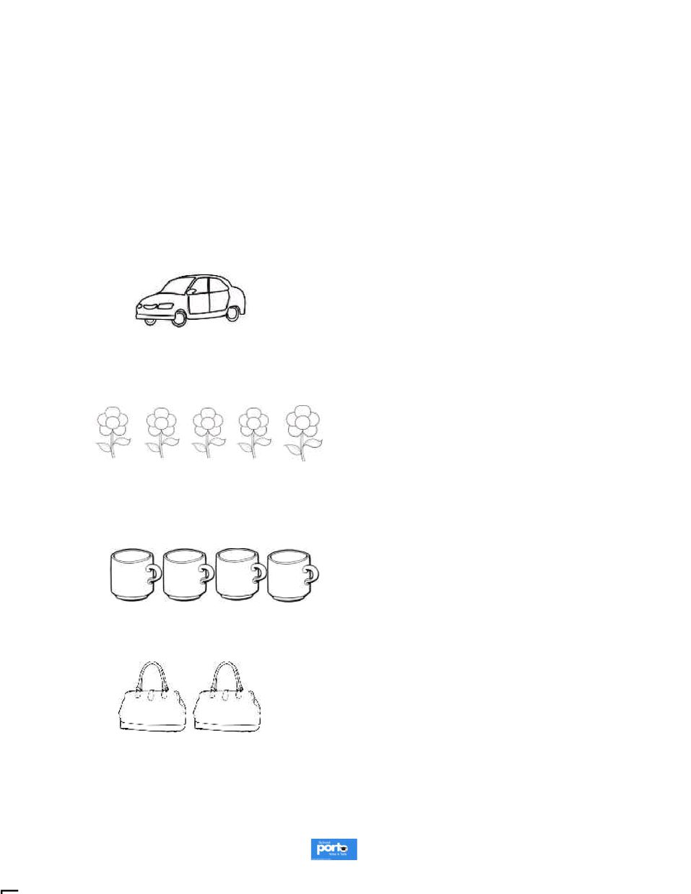
12 | P a g e

System developed by -- lule -- 0752697211,
 |  |  | . |  |  |  |  |  |  | t |  |  |  |  |  |  |  |  | h.
Powered by: |  |  |  |  |  |  |  |  |  |  |  |  |  |  | www.schoolporto.com
 |  |  |  |  |  |  |  |  |  |  |  |  |  |  | info@schoolporto.com
1 | a
 |  |  |  |  |  |  |  |  |  |  |  |  |  |  | 3 |  |  | .
 |  |  | . |  |  | i | 3 |  |  | l |  |  | u
 |  |  | . |  |  | r |  |  |  |  |  |  | i
 |  |  |  |  |  | 3 |  | 2 |  |  |  |  |  |  | 5
 |  |  |  |  |  |  |  |  |  |  |  |  |  |  |  |  |  | 2
 |  |  |  |  |  |  | I |  |  |  |  |  |  |  | 5
 |  |  |  |  |  |  |  |  |  |  |  |  |  |  |  |  |  | 0 | I
 |  |  |  |  |  |  |  |  |  |  |  |  |  |  | 4
 |  |  |  |  |  |  |  |  |  |  |  |  |  |  |  |  |  | 2

Powered by: www.schoolporto.com

System developed by -- lule -- 0752697211, info@schoolporto.com
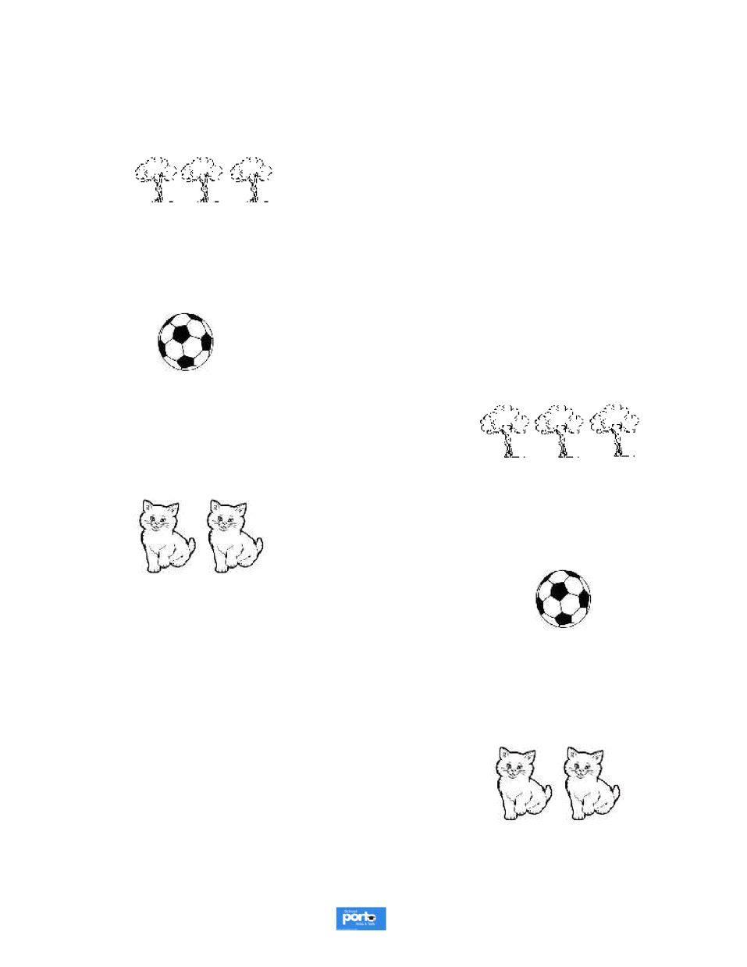
1 | a
 |  |  | . |  |  |  |  |  | t |  |  |  |  |  |  |  |  |  |  |  |  |  | s |  |  |  | .

Powered by: www.schoolporto.com

System developed by -- lule -- 0752697211, info@schoolporto.com
1 | a
 |  |  | . |  |  |  |  |  |  |  |  |  |  |  |  |  | le
 |  |  |  |  |  |  | i |  | t | t |  |  |  |  | i |  |  |  |  |  |  |  | .
 |  |  | 1.

Powered by: www.schoolporto.com

System developed by -- lule -- 0752697211, info@schoolporto.com
1 | a
 |  |  |  |  |  |  |  |  |  |  |  |  | s | . |  |  |  |  |  |  |  |  |  | e
 |  |  |  | . |  |  |  |  |  |  |  |  |  |  |  |  |  | i |  |  | t

Powered by: www.schoolporto.com

System developed by -- lule -- 0752697211, info@schoolporto.com
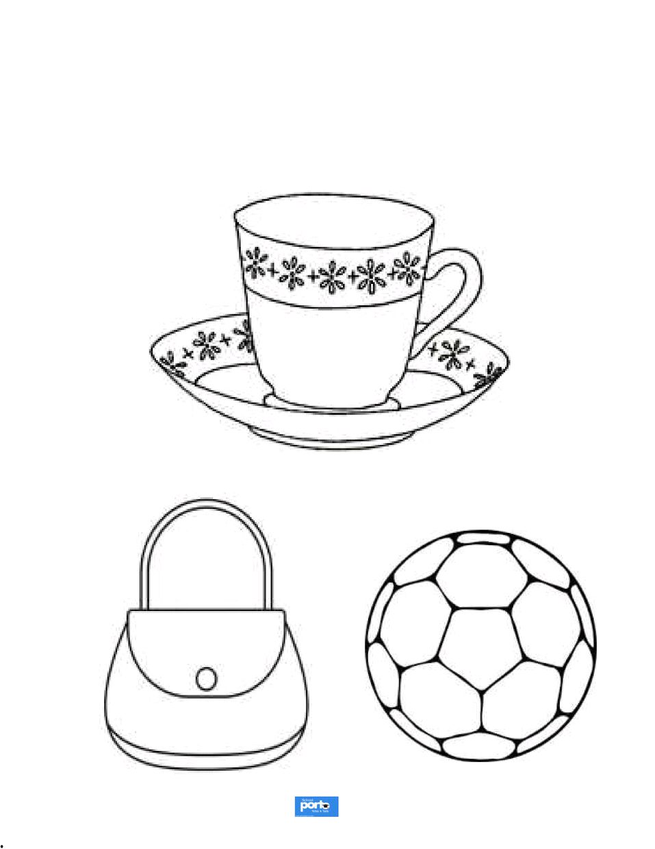
17 | P a g e
 |  |  | 1. |  |  |  |  |  |  |  |  |  |  |  |  |  |  |  |  | e |  |  | E
 |  |  |  |  |  |  |  |  |  | I

Powered by: www.schoolporto.com

System developed by -- lule -- 0752697211, info@schoolporto.com
1 | a
e
.

Powered by: www.schoolporto.com

System developed by -- lule -- 0752697211, info@schoolporto.com
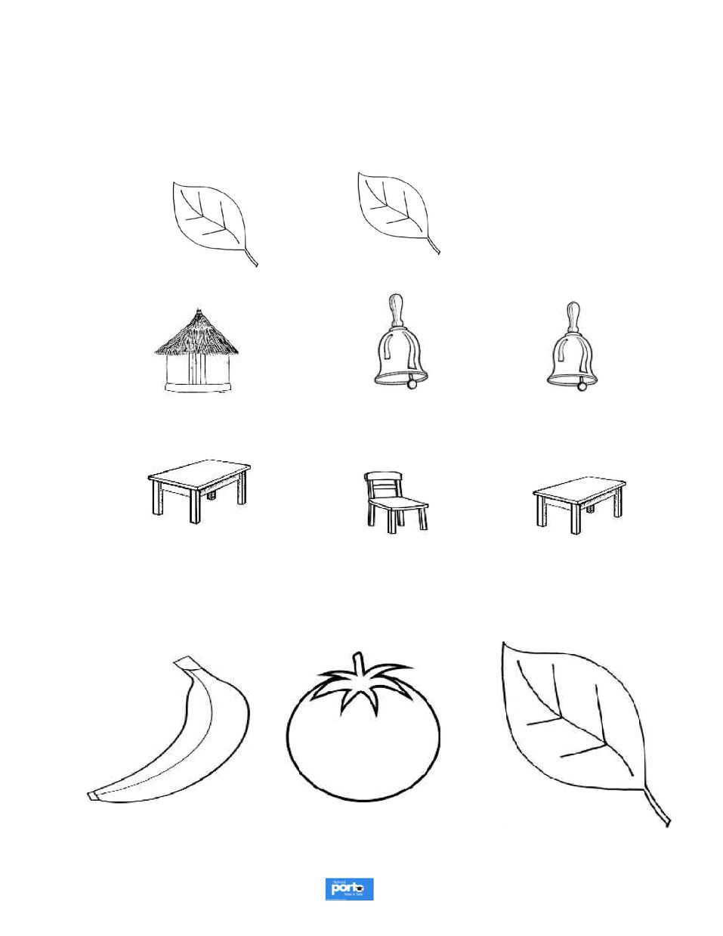
19 | P a g e
 |  |  | . |  |  | i |  |  |  |  | e | . |  |  | i
 |  |  |  |  | l |  |  |  |  |  |  |  |  |  |  | t |  | r |  | s | n
 |  |  | .
 |  |  |  |  |  | w |  |  |  |  | d

Powered by: www.schoolporto.com

System developed by -- lule -- 0752697211, info@schoolporto.com
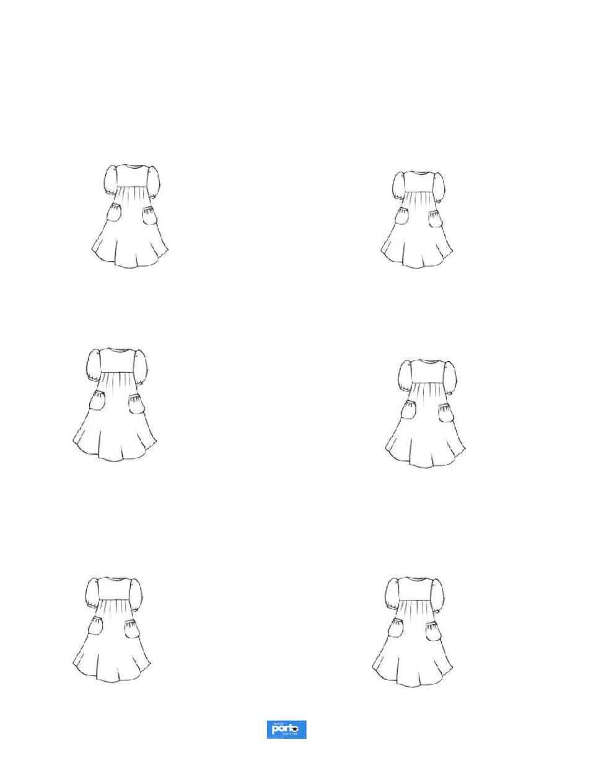
20 | P a g e
 |  |  |  |  |  |  |  |  |  | t |  |  |  |  |  |  |  |  |  |  |  |  |  | )
 |  |  |  | . |  |  | s |  | d |  | s |  | l | u | s | f |  |  |  | u |  |  | s
 |  |  |  |  |  |  |  |  |  | t |  |  |  |  |  |  |  |  |  |  |  |  | il
 |  |  |  |  |  |  |  |  | r | d |  |  |  |  |  |  |  |  |  |  |  |  | r | en
 |  |  |  |  |  |  |  |  | ll | w |  |  |  |  |  |  |  |  |  |  |  |  | r | d
 |  |  |  |  |  |  |  |  |  | n |  |  |  |  |  |  |  |  |  |  |  |  |  | l | w

Powered by: www.schoolporto.com

System developed by -- lule -- 0752697211, info@schoolporto.com
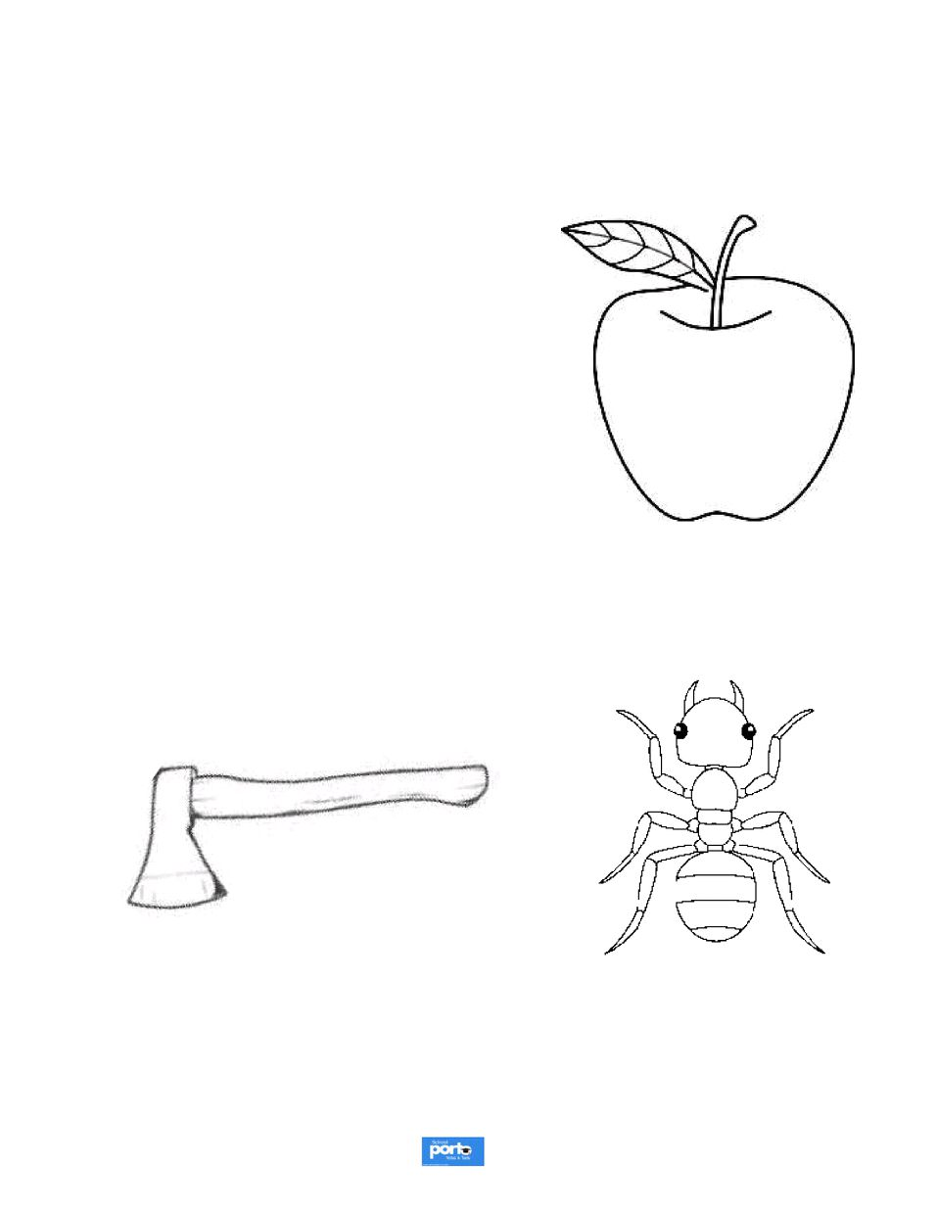
21 | P a g e
 |  |  |  |  |  |  |  |  |  |  |  |  |  |  |  |  |  |  |  |  |  |  |  |  |  |  |  |  | s | .
 |  |  |  | . |  |  |  |  |  |  | l |  | t |  |  | ‘ | ’ |  |  |  |  |  |  |  | f | i

Powered by: www.schoolporto.com

System developed by -- lule -- 0752697211, info@schoolporto.com
22 | P a g e

System developed by -- lule -- 0752697211,
 |  | . |  |  |  |  |  | l | t |  | r |  |  | ’ | i | e |  |  |  |  |  | r |  |  |  | s
 |  | .
Powered by: |  |  |  |  |  |  |  |  |  |  |  |  | www.schoolporto.com
 |  |  |  |  |  |  |  |  |  |  |  |  | info@schoolporto.com
23 | P a g e

System developed by -- lule -- 0752697211,
 |  |  | . |  |  |  |  | _ |  |  |  |  |  |  |  | i | . |  |  |  |  |  |  | _
 |  |  |  |  |  |  |  |  |  |  |  |  |  |  |  | _
 |  |  |  |  |  |  |  | _ |  |  |  |  |  |  |  | _ |  |  |  |  |  |  |  | _
 |  |  |  |  |  |  |  | _ |  |  |  |  |  |  |  | _ |  |  |  |  |  |  |  | _
 |  |  |  |  |  |  |  |  |  |  |  |  |  |  |  | _ |  |  |  |  |  |  |  | _
 |  |  |  |  |  |  |  | _ |  |  |  |  |  |  |  | _ |  |  |  |  |  |  |  | _
 |  |  |  |  |  |  |  | _ |  |  |  |  |  |  |  | _ |  |  |  |  |  |  |  | _
Powered by: |  |  |  |  |  |  |  |  |  |  |  |  |  | www.schoolporto.com
 |  |  |  |  |  |  |  |  |  |  |  |  |  | info@schoolporto.com
System developed by -- lule -- 0752697211,
 |  | 1 | . |  |  |  |  |  |  |  | i |  | s |  |  |  |  |  | t |  |  |  | s.
 |  | 1 |  |  |  | i |  | t |  |  |  |  |  |  | l |  | t | r
 |  |  |  |  |  | c |  |  |  |  |  |  |  |  | b |  |  | b
 |  |  |  |  |  | c
 |  |  |  |  |  |  |  |  |  |  |  |  |  |  | g
 |  |  |  |  |  | e
 |  |  |  |  |  | a | a |  |  |  |  |  |  |  | d
 |  |  |  |  |  | a |  |  |  |  |  |  |  |  | h |  | d
 |  |  |  |  |  | f
 |  |  |  |  |  |  |  |  |  |  |  |  |  |  |  | www.schoolporto.com |  |  |  |  |  |  |  |  |  |  |  |  | e
 |  |  |  |  |  | Powered by: |  |  |  |  |  |  |  |  |  |  |  |  |  | 2 |  |  |  |  |  |  | | | a
 |  |  |  |  |  |  |  |  |  |  |  |  |  |  |  | info@schoolporto.com
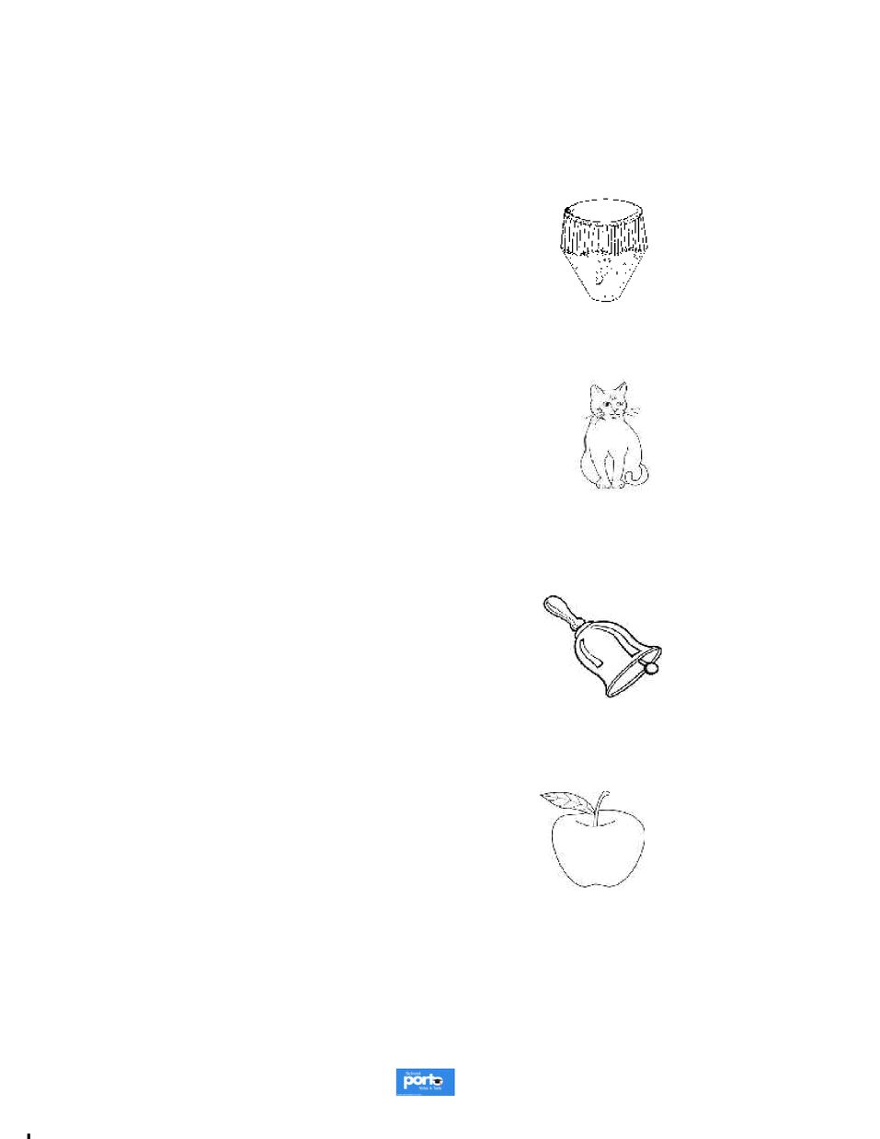
25 | P a g e
 |  |  |  | .
 |  |  | 1 |  |  |  |  |  |  |  |  |  |  |  |  |  |  |  |  | .

Powered by: www.schoolporto.com

System developed by -- lule -- 0752697211, info@schoolporto.com
2 | a
 |  |  | . |  |  |  |  |  |  |  | _ |  |  |  | e | . |  |  |  |  | _
 |  | 1 |  |  |  |  |  |  | y |  |  |  |  | i
 |  |  |  |  |  |  |  |  |  |  |  |  |  |  | _
 |  |  |  |  |  |  |  |  |  |  | _ |  |  |  | _ |  |  |  |  |  | _
 |  |  |  |  |  |  |  |  |  |  | _ |  |  |  | _ |  |  |  |  |  | _
 |  |  |  |  |  |  |  |  |  |  | _ |  |  |  | _ |  |  |  |  |  | _
 |  |  |  |  |  |  |  |  |  |  | _ |  |  |  | _ |  |  |  |  |  | _

Powered by: www.schoolporto.com

System developed by -- lule -- 0752697211, info@schoolporto.com
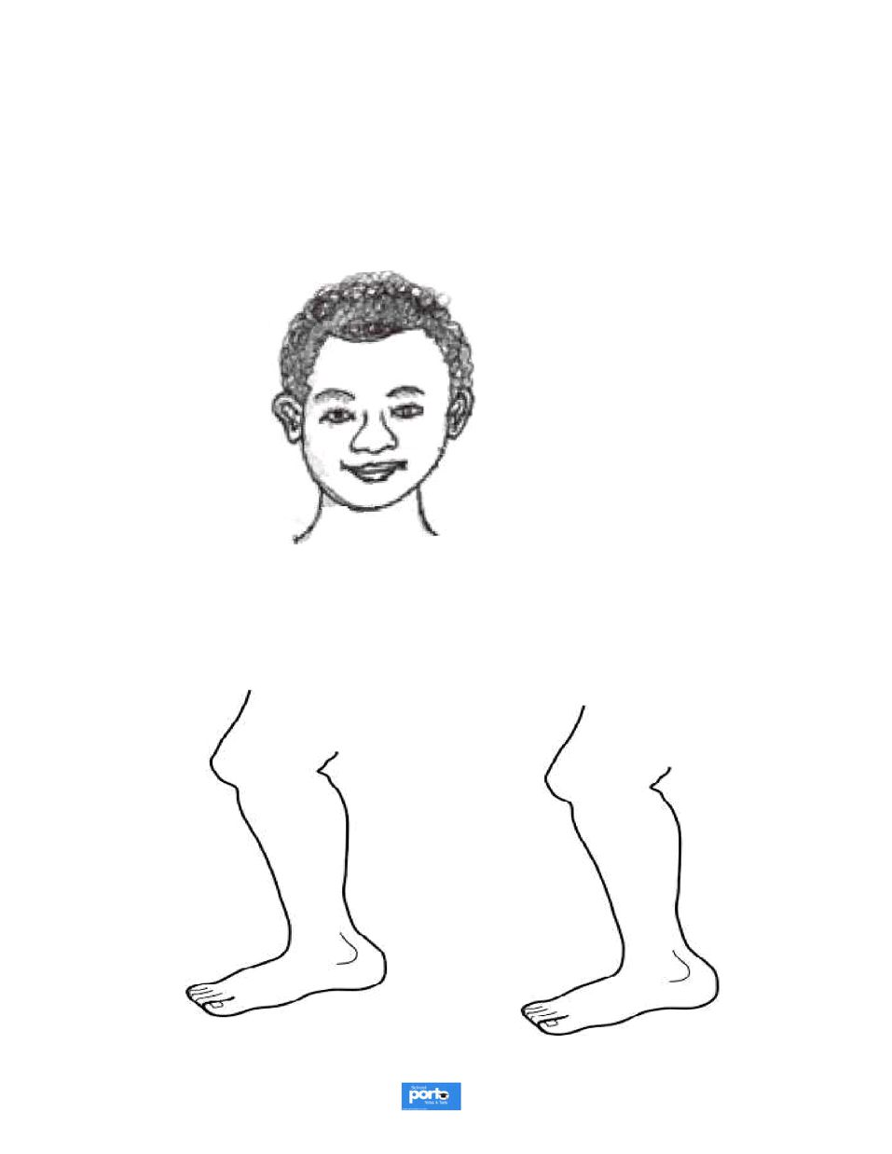
2 | a
 |  |  |  |  |  |  | L |  |  |  |  |  |  | I | S |  |  |  |  |  |  |  |  |  | lly
 |  |  | . |  |  |  |  |  | t |  |  |  |  |  |  |  |  |  |  |  | s
 |  |  |  |  |  |  |  |  |  |  |  |  |  | y
 |  |  | . |  |  |  |  |  |  |  |  |  |  | l |  | s

Powered by: www.schoolporto.com

System developed by -- lule -- 0752697211, info@schoolporto.com
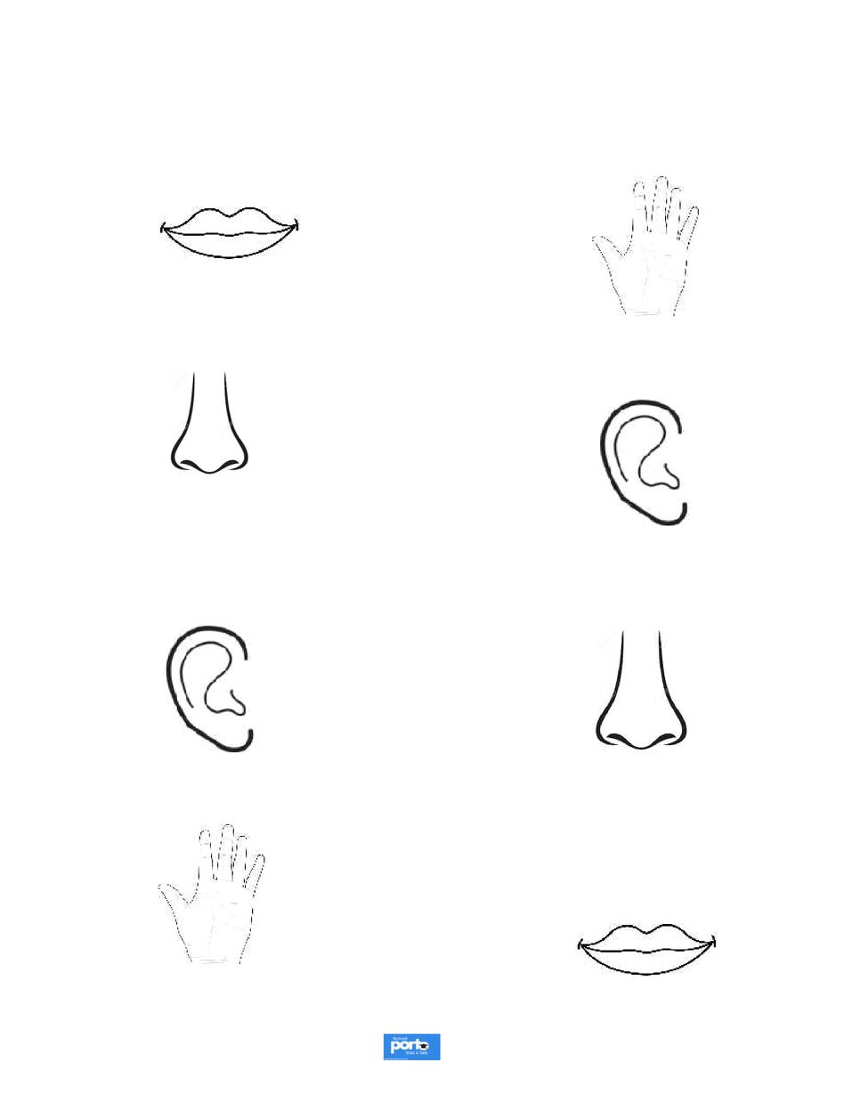
28 | P a g e
 |  |  |  | . |  |  |  |  |  |  |  |  |  |  | s |  |  |  |  |  |  |  | y |  |  |  |  | s

Powered by: www.schoolporto.com

System developed by -- lule -- 0752697211, info@schoolporto.com
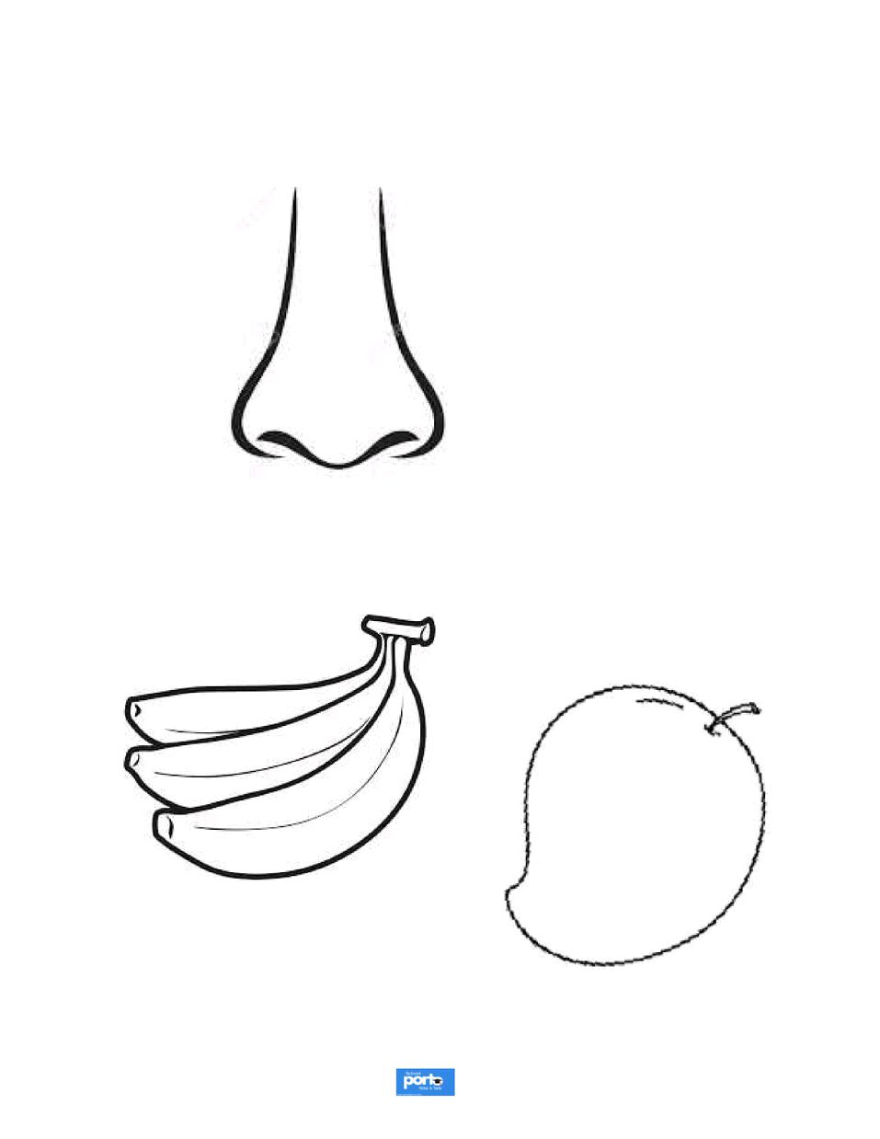
2 | a
 |  |  |  |  |  |  |  |  |  | t |  |  |  |  |  | e
 |  |  | .
 |  |  | . |  |  |  |  |  |  |  |  |  |  |  |  | ts

Powered by: www.schoolporto.com

System developed by -- lule -- 0752697211, info@schoolporto.com
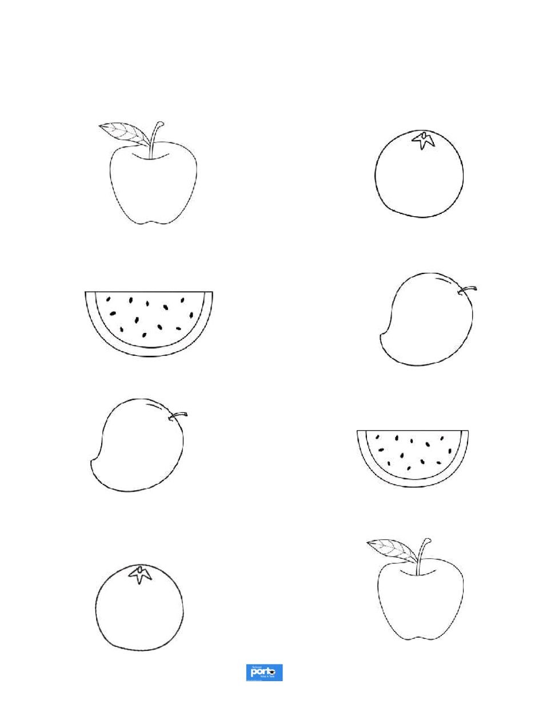
30 | P a g e
 |  |  |  |  |  |  |  |  |  |  |  |  |  |  |  |  |  |  |  |  |  |  | i | s

Powered by: www.schoolporto.com

System developed by -- lule -- 0752697211, info@schoolporto.com
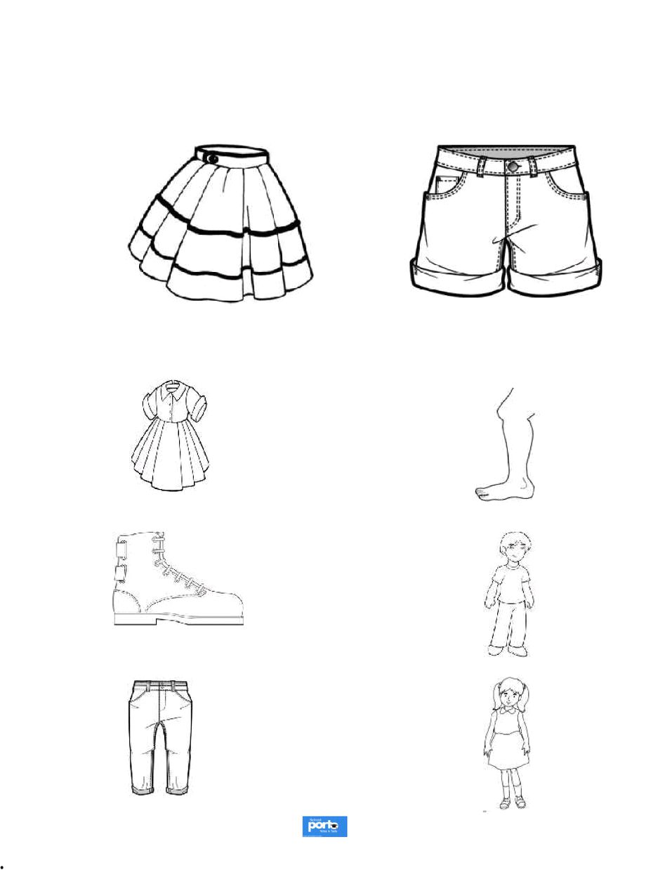
31 | P a g e
 |  |  |  |  |  |  |  |  |  |  |  |  |  | i |  |  |  |  |  |  |  | r
 |  |  |  | . |  |  |  |  |  |  |  | t |  |  |  |  |  |  |  | i
 |  |  |  | . |  |  |  |  |  |  |  |  |  |  |  |  |  |  |  |  |  | s

Powered by: www.schoolporto.com

System developed by -- lule -- 0752697211, info@schoolporto.com
3 | a
 |  | 1. |  |  | _ |  |  |  | G |  | . |  |  | _ |  |  |  |  |  |  | _
 |  |  |  |  |  |  | I
 |  |  |  |  |  |  |  |  |  | i
 |  |  |  |  |  |  |  |  | _
 |  |  |  |  | _ |  |  |  | _ |  |  |  |  | _ |  |  |  |  |  |  | _
 |  |  |  |  | _ |  |  |  | _ |  |  |  |  | _ |  |  |  |  |  |  | _
 |  |  |  |  |  |  |  |  |  |  | i |  |  | s | i | k

Powered by: www.schoolporto.com

System developed by -- lule -- 0752697211, info@schoolporto.com
3 | a
 |  |  |  |  |  | _ |  |  |  | _ |  |  | te |  |  |  |  |  | _ |  | d
 |  |  | . |  | r |  |  |  |  |  | t | r |  |  |  | k
 |  |  | . |  |  |  |  |  |  |  |  | i | _
 |  |  |  |  |  | _ |  |  |  | _ |  |  | _ |  |  |  |  |  | _
 |  |  |  |  |  | c |  |  |  | l |  |  | t
 |  |  | . |  |  |  |  |  |  | s |  |  |  | i

Powered by: www.schoolporto.com

System developed by -- lule -- 0752697211, info@schoolporto.com
3 | a
 |  |  |  |  |  | c |  |  |  |  |  |  |  |  |  |  |  |  |  |  |  |  |  |  |  |  | d
 |  |  | . |  | r |  |  |  |  | s |  |  | t |  |  |  |  | i

Powered by: www.schoolporto.com

System developed by -- lule -- 0752697211, info@schoolporto.com
35 | P a g e
 |  |  |  |  |  |  |  |  |  |  |  |  |  | e |  |  |  | d |  |  |  | _
 |  |  | .
 |  |  | . |  |  |  |  |  | _ |  |  |  | i
 |  |  |  |  |  |  |  |  |  |  | _ |  |  |  |  |  |  |  |  |  |  | _

Powered by: www.schoolporto.com

System developed by -- lule -- 0752697211, info@schoolporto.com
36 | P a g e
 |  |  |  |  | _ |  | n |  |  |  |  | te |  | k |  |  |  |  |  |  | _
 |  |  | . |  |  |  |  |  | r | _ |  |  | _ |  |  |  | . | _
 |  |  | .
 |  |  |  |  |  |  |  |  | _ |  |  |  |  | __
 |  |  |  |  | _ |  |  |  |  |  |  |  |  |  | _ |  |  | _ |  |  | _

Powered by: www.schoolporto.com

System developed by -- lule -- 0752697211, info@schoolporto.com
3 | a
 |  |  | . |  |  |  |  |  | e
 |  | 1

Powered by: www.schoolporto.com

System developed by -- lule -- 0752697211, info@schoolporto.com
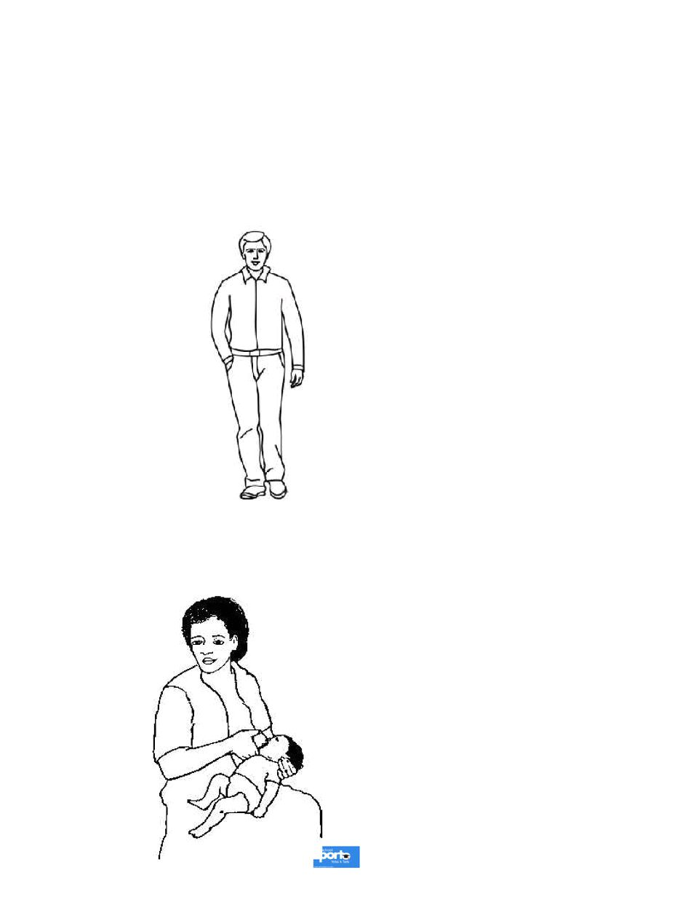
38 | P a g e

System developed by -- lule -- 0752697211,
 |  |  | . |  | h |  |  |  |  | I | L |  | r |  |  |  |  |  |  |  |  |  | T
 |  |  | . |  |  | h |  |  |  |  | t |  |  |  |  |  |  |  |  |  |  |  | y
Powered by: |  |  |  |  |  |  |  |  |  |  |  | www.schoolporto.com
 |  |  |  |  |  |  |  |  |  |  |  | info@schoolporto.com
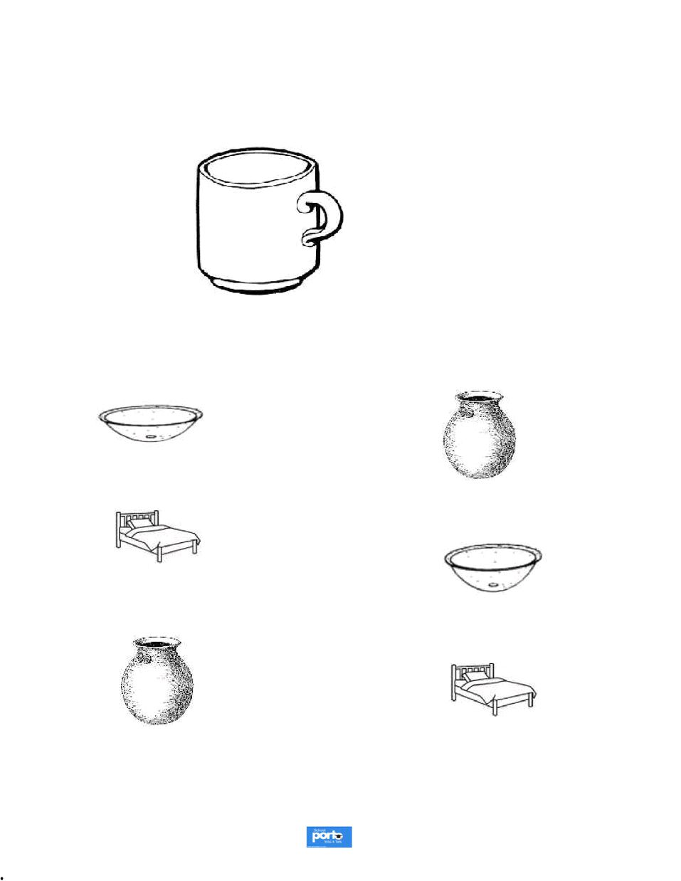
39 | P a g e

System developed by -- lule -- 0752697211,
 |  |  |  |  |  |  |  |  |  |  |  |  |  |  |  |  |  |  | p
 |  |  |  | . |  |  |  |  |  |  |  |  | t |  |  | r
 |  |  |  | . |  |  |  |  |  |  |  |  |  |  |  |  |  |  | e
Powered by: |  |  |  |  |  |  |  |  |  |  |  |  |  |  |  |  |  | www.schoolporto.com
 |  |  |  |  |  |  |  |  |  |  |  |  |  |  |  | info@schoolporto.com
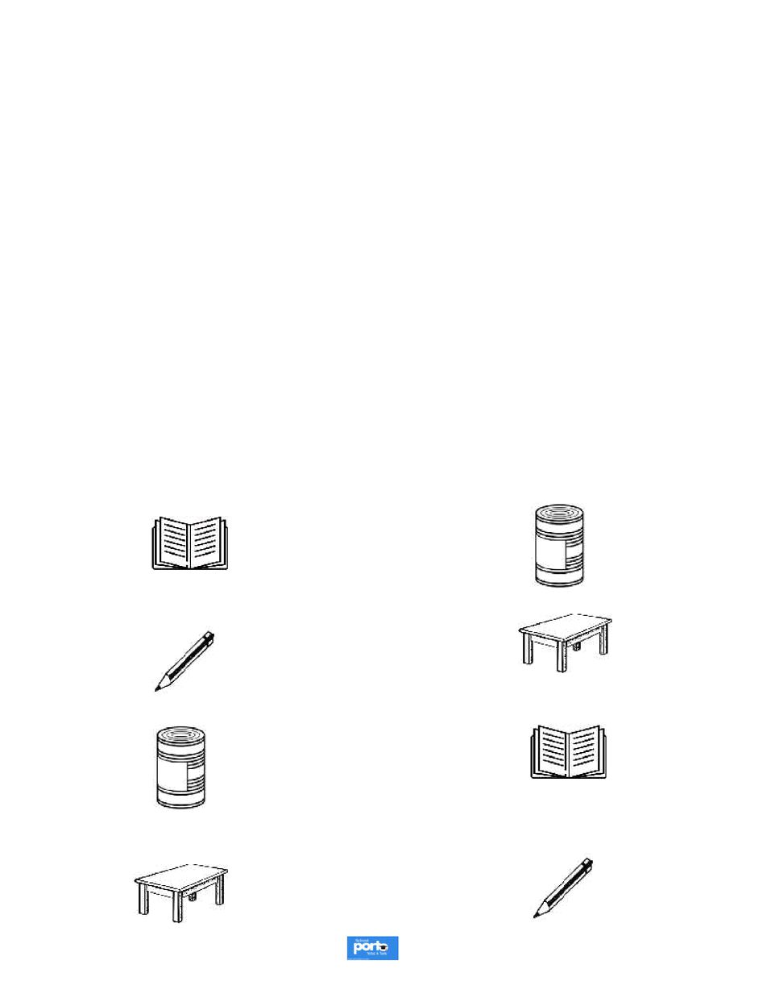
4 | a
 |  |  |  |  |  |  |  |  |  |  |  |  |  |  |  |  | le | .
 |  |  | . |  |  |  |  |  |  |  |  | t |  | t
 |  |  |  |  |  |  |  |  |  |  |  |  |  |  |  |  | e

Powered by: www.schoolporto.com

System developed by -- lule -- 0752697211, info@schoolporto.com
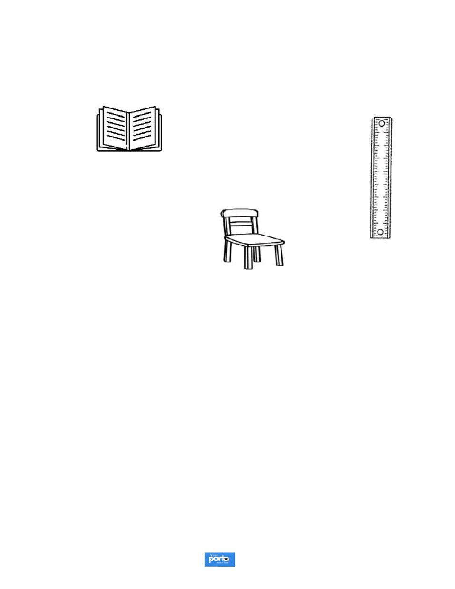
41 | P a g e

System developed by -- lule -- 0752697211,
 |  |  | . |  |  |  | l |  | ass |  |  | s | le | s |  | I |  | s
 |  |  | . |  |  |  | ab | c |  |  |  | id |  |  | ss |  |  | 3
 |  |  |  |  |  |  |  |  |  |  |  |  |  |  |  |  |  | l |  | .
 |  |  |  |  |  |  |  |  |  |  |  |  |  | cl |  |  |  | o | c |  | ass
 |  |  |  |  |  |  |  |  | Powered by: |  |  |  |  |  |  | www.schoolporto.com
 |  |  |  |  |  |  |  |  |  |  |  |  |  | info@schoolporto.com

