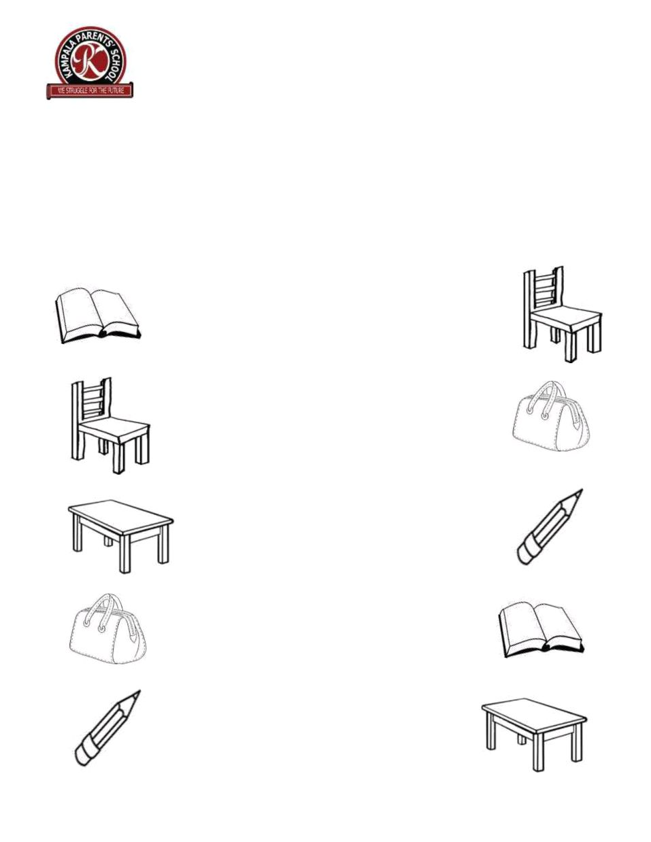
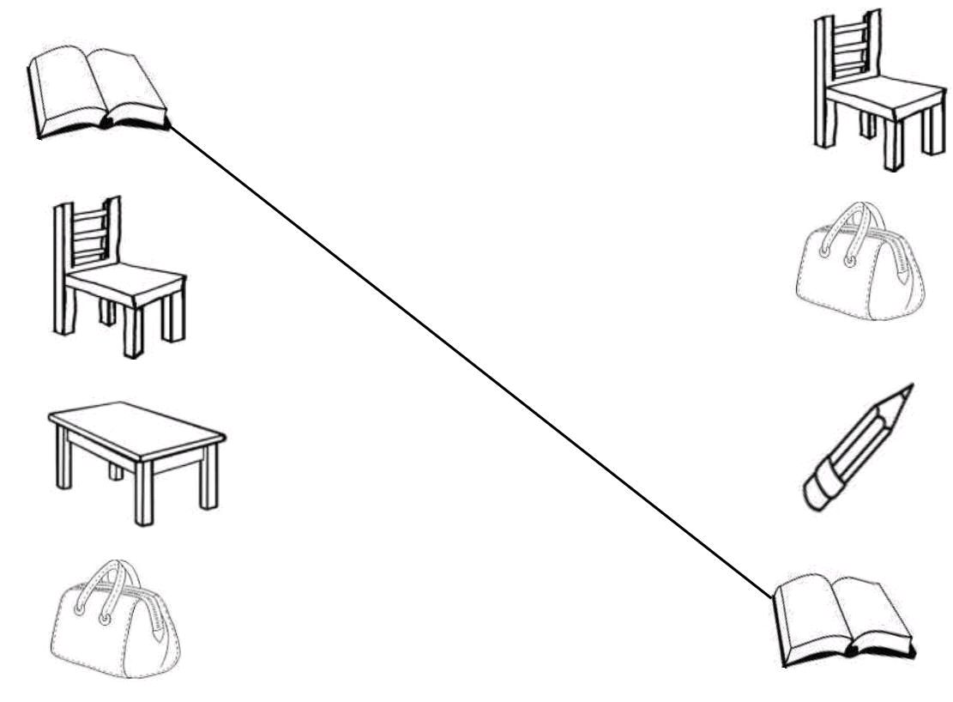
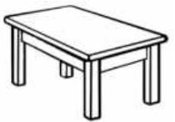
KAMPALA PARENTS’ SCHOOL 2004

BABY CLASS REVISION WORK
ENGLISH WORK – SET SEVEN

Name: ____________________________________ Stream: ______

Date: ____________________________________________________

Match the same pictures.

***** END*****
KAMPALA PARENTS’ SCHOOL 2004

BABY CLASS REVISION WORK
COLOURING – SET SEVEN

Name: ____________________________________ Stream: ______

Date: ____________________________________________________

Colour the mango.

***** END*****
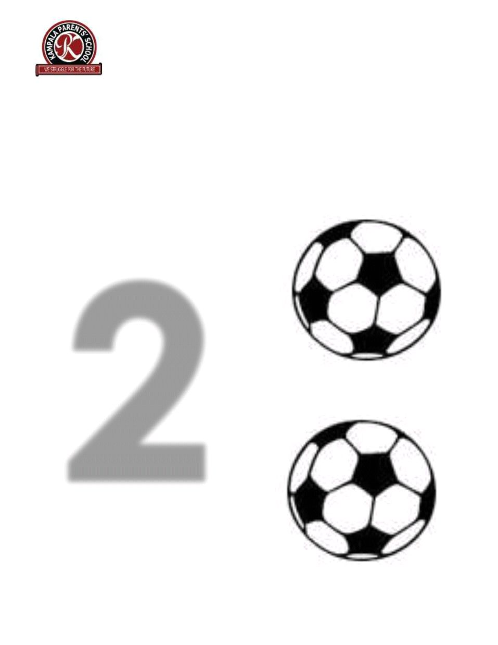
KAMPALA PARENTS’ SCHOOL 2004

BABY CLASS REVISION WORK
NUMBERS – SET SEVEN

Name: ____________________________________ Stream: ______

Date: ____________________________________________________

Colour and count.

***** END*****
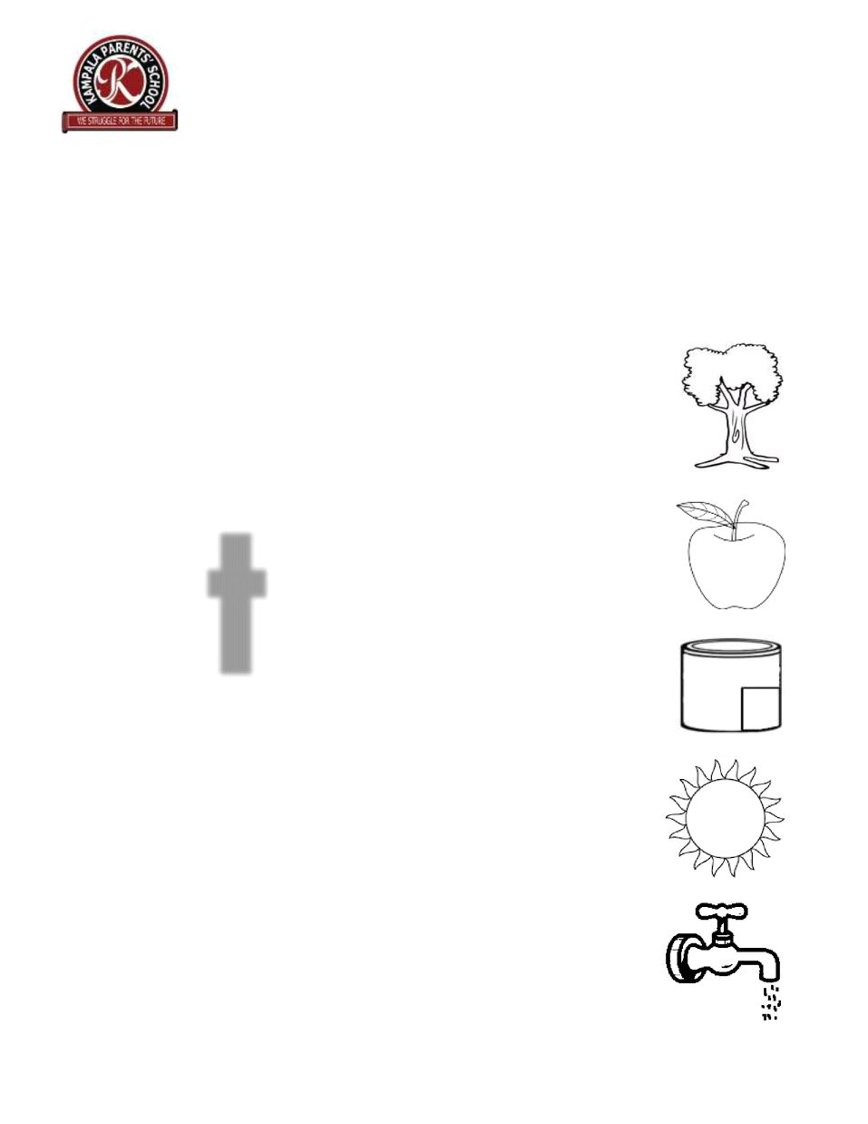
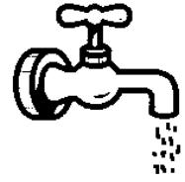
KAMPALA PARENTS’ SCHOOL 2004

BABY CLASS REVISION WORK
READING – SET SEVEN

Name: ____________________________________ Stream: ______

Date: _____________________________________________________

Match t to the friends.

***** END*****

