SUCCESS INTEGRATED NURSERY SCHOOL
Internal End of First Term Examinations 2020
English 3-4 years

Name ________________________Stream__________
1. Match the same pictures.
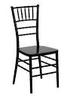
2. Copy and write.
a b t o

3. Match the same letters.
a f
b c
c a
f b
4. Put the missing parts.

5. Circle the same letters.

a b a
c c d
b f b

