SUCCESS INTEGRATED NURSERY SCHOOL
Internal End of First Term Examinations 2020
Literacy 3-4 years

Name ________________________Stream__________
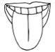
1. Match the same pictures.

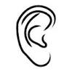
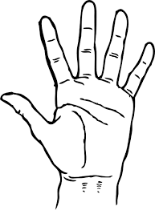

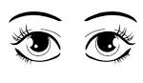

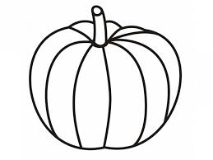
2. Tell these fruits.
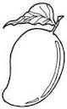

3. Shade the sources of light.

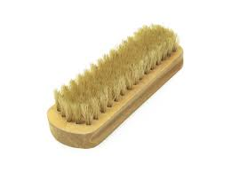
4. Circle the same pictures.
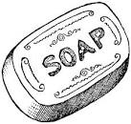
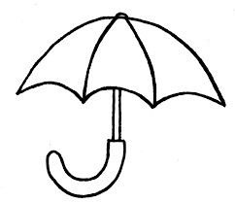

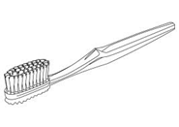
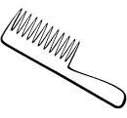
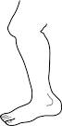
5. Colour me well.

6. Trace a skirt.

