LOHANA SCHOOLS
REVISION WORK FOR BABY: 2020
ACTIVITY TWO
LOHANA SCHOOLS
Interacting, exploring, knowing and using my environment. - Learning Area 2 – Drawing
I like colouring.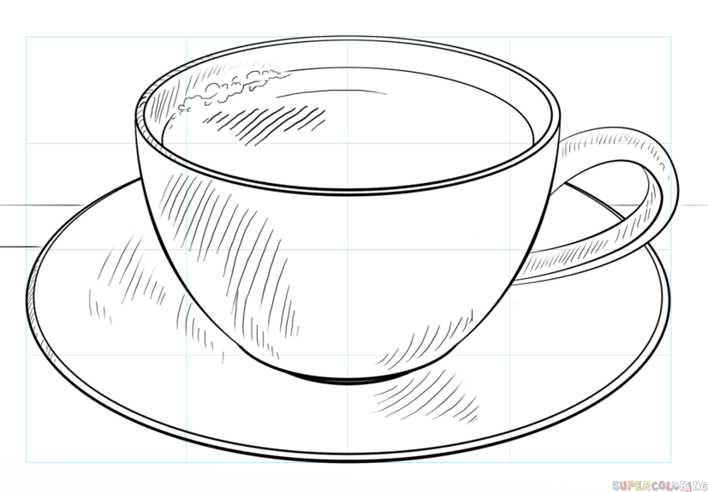

REVISION WORK FOR BABY ACTIVITY TWO:2020
Developing and using my language appropriately. Learning Area 5 – (English)

My name is …………………………………………………….
Read, colour and trace.

REVISION WORK FOR BABY ACTIVITY TWO: 2020
Developing and using my language appropriately. Learning Area 5 – (Reading)
My name is …………………………………………………….
Sound and match.
s t
a i
t s
i a

