NABBUNGA FOUNTAIN OF EDUCATION DAY AND BOARDING PRIMARY SCHOOL END OF TERM II DRAWING FOR BABY CLASS 2016
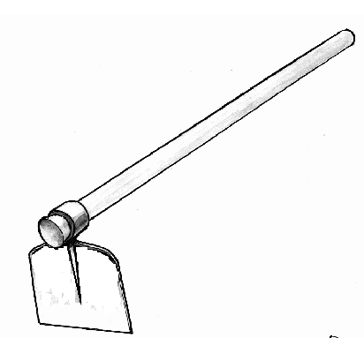
NAME: ________________________________________________________
Colour me please.

hoe hoe
______ ______
______ ______
______ ______

