**NABBUNGA FOUNTAIN OF EDUCATION DAY AND BOARDING PRIMARY SCHOOL END OF TERM II L.A 1 (SST) FOR BABY CLASS 2016**

**NAME: ________________________________________________________**

People who protect and take care of us.

1. 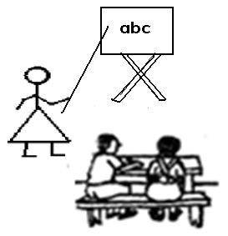**Match the same.**

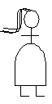

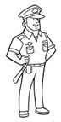





1. **Circle the correct word for the picture.**

mother mat



net nurse

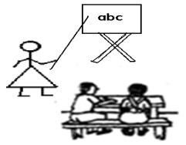

teacher tin



fan father

1. **People found at home write and draw.**

|  |  |  |
| --- | --- | --- |
| f | father |  |
|  |  |  |

|  |  |  |
| --- | --- | --- |
| m | mother |  |
|  |  |  |

|  |  |  |
| --- | --- | --- |
| g | grand mother |  |
|  |  |  |

|  |  |  |
| --- | --- | --- |
| g | grand father |  |
|  |  |  |

Things we use at home.

1. **Read and match.**

axe

bed

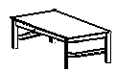cup

mat



chair



table



broom

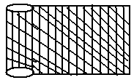

jug

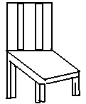

ball

Animals at home

1. **Circle the correct word for the picture.**

stool sheep

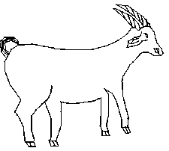

goat doll

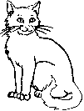

cup cat

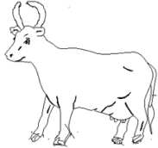

cow tree

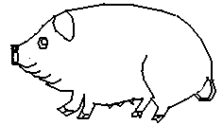

pot pig



rabbit rat

1. **Match animal to its sound.**

cow meee

cat baaaa

sheep moooo

goat mew mew

Means of transport

1. **Match the same.**

train bicycle

bus aeroplane

car boat

boat train

aeroplane bus

bicycle car

1. 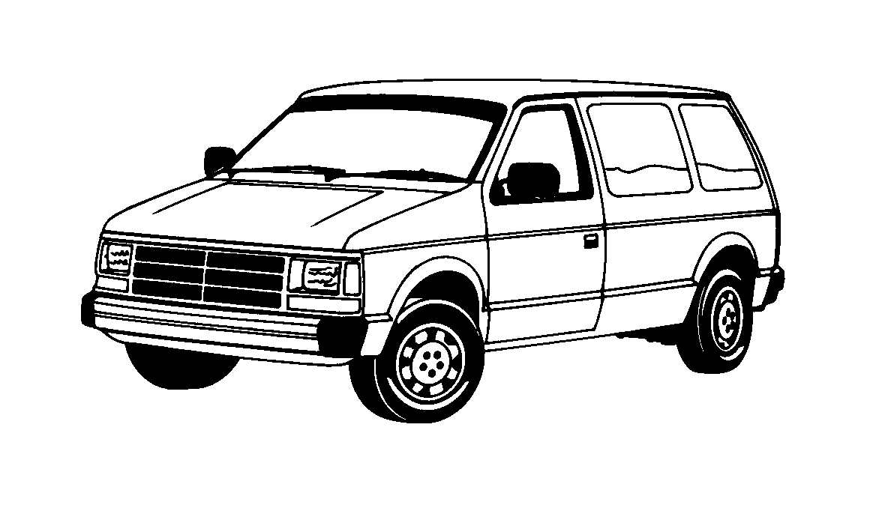**Circle the correct word for the picture.**

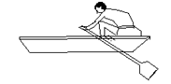cup car

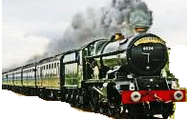boat boy

tree train

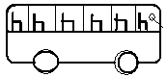

bus bag



axe aeroplane **END**