**NABBUNGA FOUNTAIN OF EDUCATION DAY AND BOARDING PRIMARY SCHOOL END OF TERM II L.A 2 (ENGLISH) FOR BABY CLASS 2016**

**NAME: ________________________________________________________**

1. **Write small letters a – z.**

a ___ ___ ___ ___

___ ___ ___ ___ ___

___ ___ ___ ___ ___

___ ___ ___ ___ ___

___ ___ ___ ___ ___

___

1. **Fill in the missing letters.**

t___n mo___n

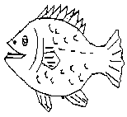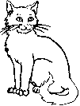

f___sh c___t

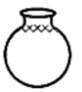

su___ p___t

1. 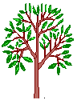**Match the belongings.**

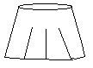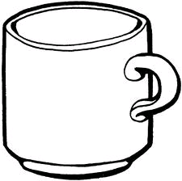



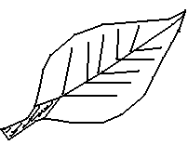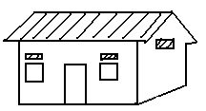

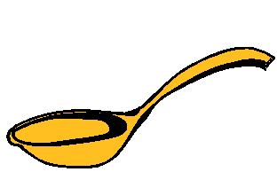



1. **Circle a correct word for a picture.**



girl eetr uns book

irgl tree sun oobk

1. **Read and draw.**

|  |  |
| --- | --- |
| That is a tin. | That is a cup. |
|  |  |
| That is a bottle. | That is a stool. |
|  |  |
| That is a stick. | That is a pencil. |
|  |  |

1. **Match capital to small letters.**

H a

E c

M j

J h

C e

A m

1. **Complete these sentences.**

This is a ______________.



door

bell

book

pencil

broom

This is a ______________.

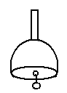

This is a ______________.

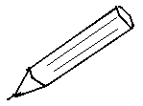

This is a ______________.



This is a ______________.

1. **Match the same pictures and write.**

boy

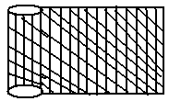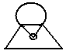

___________



___________



___________



___________



___________

1. **Make sentences using It is………**

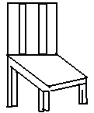

It is a chair.

____________________________

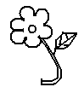

____________________________



____________________________

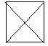

____________________________

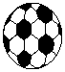

____________________________

**END**