**NABBUNGA FOUNTAIN OF EDUCATION DAY AND BOARDING PRIMARY SCHOOL END OF TERM II L.A 3 FOR BABY CLASS 2016**

**NAME: ________________________________________________________**

1. **Match picture to word.**

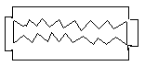

stone

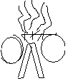

knife

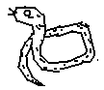

razorblade

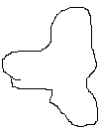

fire

snake

1. **Name these body parts.**

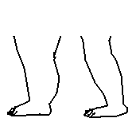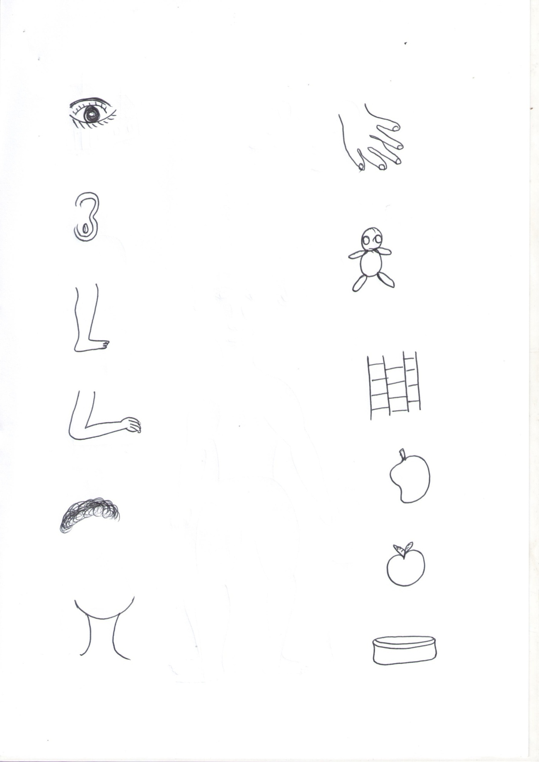

_____________ _______________



_____________ _______________

**leg, nose, ear,**

**mouth, eye**



_____________

1. **Read and draw these foods we eat.**

fish

______

egg yam

bean ______ ______

______ cassava

______

1. **Match the same.**

tomato pawpaw

apple orange

mango tomato

pawpaw apple

orange mango

1. **Circle for the given picture.**

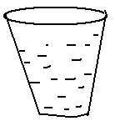

water wall

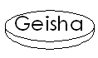

sun soap

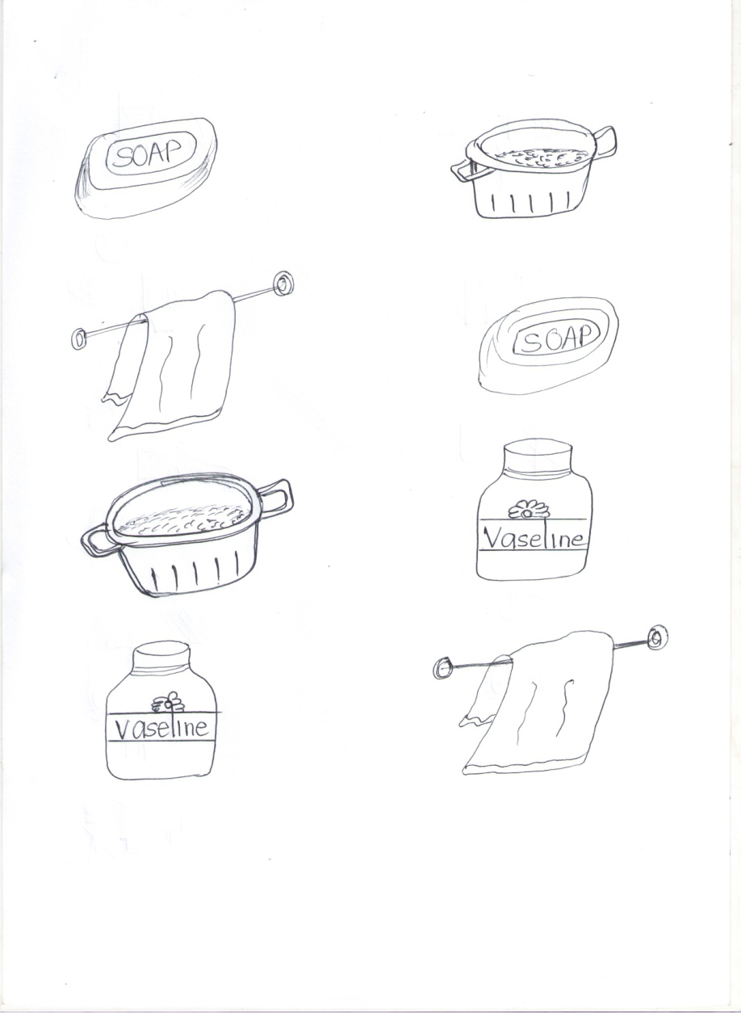

towel tin



stick sponge

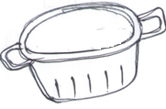

basin ball

1. 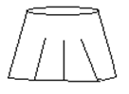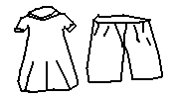**Match the same.**

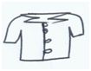





1. **Draw and write.**

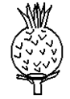

pineapple

______ __________

______ __________

**END**