**NABBUNGA FOUNTAIN OF EDUCATION DAY AND BOARDING PRIMARY SCHOOL END OF TERM II L.A 4 FOR BABY CLASS 2016**

**NAME: ________________________________________________________**

1. **Fill in the missing numbers.**

1

2 ___ 4 ____

6 ___ 8 ___

10

1. **Draw eggs.**

4 = 2 =

3 = 4 =

1 = 5 =

1. **Match the same sets.**

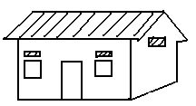

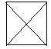













1. **Circle the same numbers.**

0 4 7

0 9 7

1 9 5

2 0 8

2 4 3

6 0 8

1. **Count and match.**

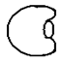

6



5

3



1

2

4

1. **Match a shape to a word.**

triangle

square

circle

kite

oval

1. **Count and write.**



______________

______________



______________

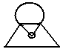

______________

______________

1. **Name these sets.**

A set of ____________

books

tins

cups

beds

A set of ____________



A set of ____________

A set of ____________

1. **Match and write the same.**

1 9 ___

2 8 ___

3 7 ___

5 1 1 .

6 2 ___

7 3 ___

8 5 ___

9 6 ___

**END**