**Mentor Kindergarten & Primary School**

**Home work**

**Baby class**

**Name: _____________________________________ 10th /7/2018**

Circle the odd man out.









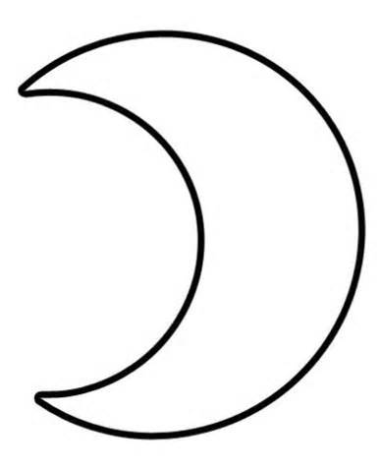









Join the dots and form shapes.

1

10

9

8

7

7

5

4

6

3

2