SUCCESS INTEGRATED NURSERY SCHOOL
Internal End of First Term Examinations 2020
English 4-5 years

Name ________________________Stream__________
1. Write the next letter.
a ____
a b ____
a b c ____
a b c d ____
2. Tick (√ ) the given picture.
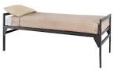 | 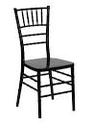  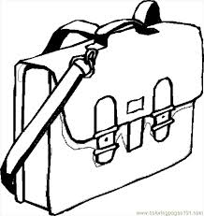
 | 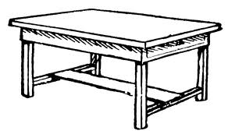
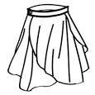 | 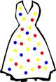
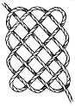 | 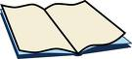  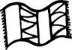

3. Circle the same words.
chair moon chair
bag doll doll
mat mat fan
table shirt table
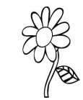
4. Match the same pictures and draw.

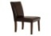

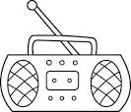

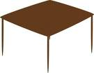

5. Put the missing part.

6. Fill in the missing letter.
p __ t | c __ p
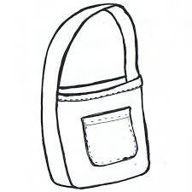  b __g | ch__ir
fl__wer | 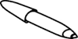  p__n

7. Read and draw.

book | cat | pot | pencil | mat | mug

8. Join the dots.
a b c

d
e

f g h

