**Mentor Kindergarten & Primary School**

**Home work**

**Baby class**

**Name: _____________________________________ 6th /7/2018**

**Health habits**

Shade the dangerous objects.



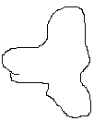

Numbers

Circle the correct number.

1

2 s

3

4

5

English

Draw and copy.



tin