Mentor Kindergarten & Primary School
Home work
Middle class
Name: _____________________________________ 13th /7/2018
Numbers.
Copy again.
0 | 1 | 2

Colour the fruits.
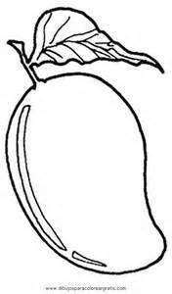
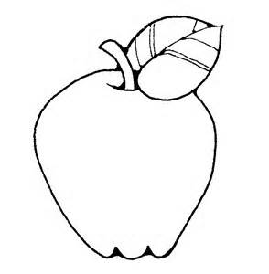

Copy and draw.
mat

